EEM Release Notes

for

Version 3.17 released as of

15/06/2018 11:58 AM

Table of Contents

1. Introduction 3

2. Compatible Products 3

3. Installation Steps 3

4. New Features 3

5. Bug Fixes 4

6. Known Problems and Workarounds 4

# Introduction

This document communicates the major new features, bug fixes and setup changes in this release of the EEM. It also documents known problems and workarounds.

# Compatible Products

This release has been tested on the following platforms and products:

* Windows OS 2012 on the Server
* Windows OS 7.0 on the Client
* MS SQL Server 2012
* Internet Explorer 11

# Installation Steps

* Backup the EEM Production Binaries for future use
* Download the Release rar files from the git hub.
* Stop the EEM Production Website on IIS
* Extract any one rar file which will automatically extract all required EEM binaries and related files.
* After successful extraction, copy the files to the EEM release location on the EEM server.
* Go to the Scripts\Upgrade folder in the released location and run Setup.cmd
* Restart the EEM Production Website on IIS

# New Features

* 1. **Feature Description:**

Streamline all notifications and Manage report UI Enhancement

Enhance Manage Report UI to have 3 tabs like Manage regular jobs, Manage report jobs and Monitor jobs.

Monitor jobs- Should list all the available Jobs running and status/history.

Manage regular jobs- Should list all the regular jobs apart from report related jobs and able to add/update the regular jobs.

Manage report jobs- Should list all the report related jobs and able to add/update the jobs.

Scheduler for the job should be similar as outlook scheduler

The scheduled Mail should be send only on business days

Retire exchange type mailing and use only use SMTP type mailing

**Streamline all notifications changes:**

* + Exchange mailing service feature is retired. So please configure the SMTP email in system preference

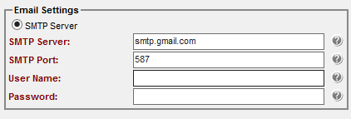

* + Please make sure Emanger database owner is same as master database owner. If not change the ownership of Emanger by running the below script

Script: EXEC sp_changedbowner 'master database owner name'

Example: EXEC sp_changedbowner 'sa'

* + While running SQL Script command in EEM\Scripts\Upgrade\setup.cmd please provide the EEM installed path without fail

Sample:

Setup.cmd <ServerName> <UserName> <Password> <EEM Release Path>

<Auto Import>

**Example**:



**Manage report UI enhancement changes:**

* + Manage Report menu is changed to Manage Jobs
  + On click of Manage Jobs new UI with 3 tabs (Monitor jobs, Manage regular jobs and Manage report jobs) will be provided on default Monitor job tab will be loaded
  + Monitor job UI will list all the available jobs with status and you can see the status history for each job using view history button
  + Manage regular jobs and Manage report jobs will contains list of jobs created according to its type and you will have ability to create, edit and delete the jobs
  + Three types of Job can be added, and each will have required different job details
    - Type 1 – Mail Notification 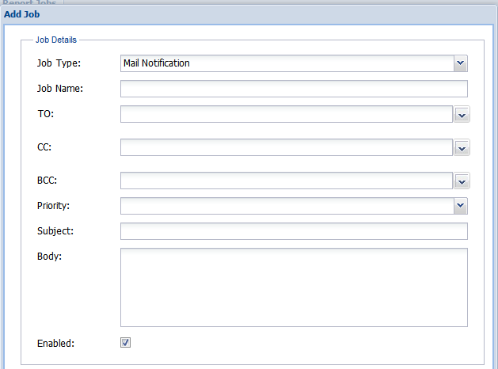
    - Type 2 – SQL Execution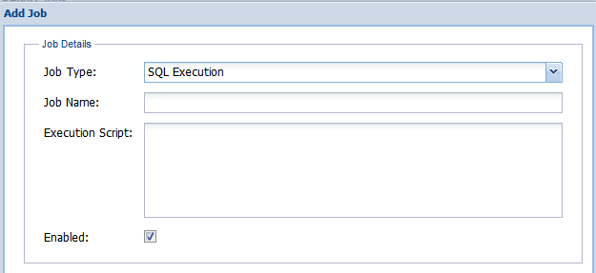
    - Type 3 – Report Delivery (This type can be added only Manage report job tab)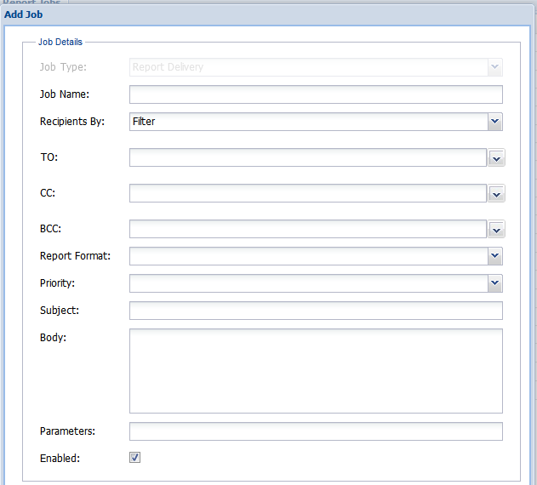
  + All the task type will have same type of scheduling like outlook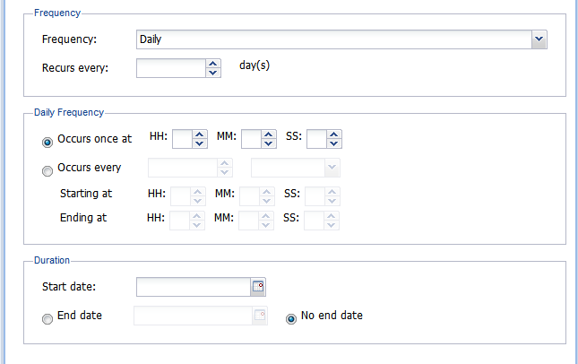
  1. **Feature Description:**

Mailing facility from MSM and Request tracker for EEM. Design our own mailing window with attachment feature to send mail

**Changes:**

* + On click of the "Email this Bug" icon in MSM or "Email" in Request Tracker a new window will be displayed which required basic detail to send a mail.
  + To, CC, Bcc fields will have dropdown and text box, the dropdown will list all the email ids of current employee and in text box you can type non-employee mail ids with comma or semicolon separator
  + On click of Attachment button, new window will be opened where you can attach multiple file
  + You can replace the body of the mail in <Enter your mail body here> space

Demo Screen

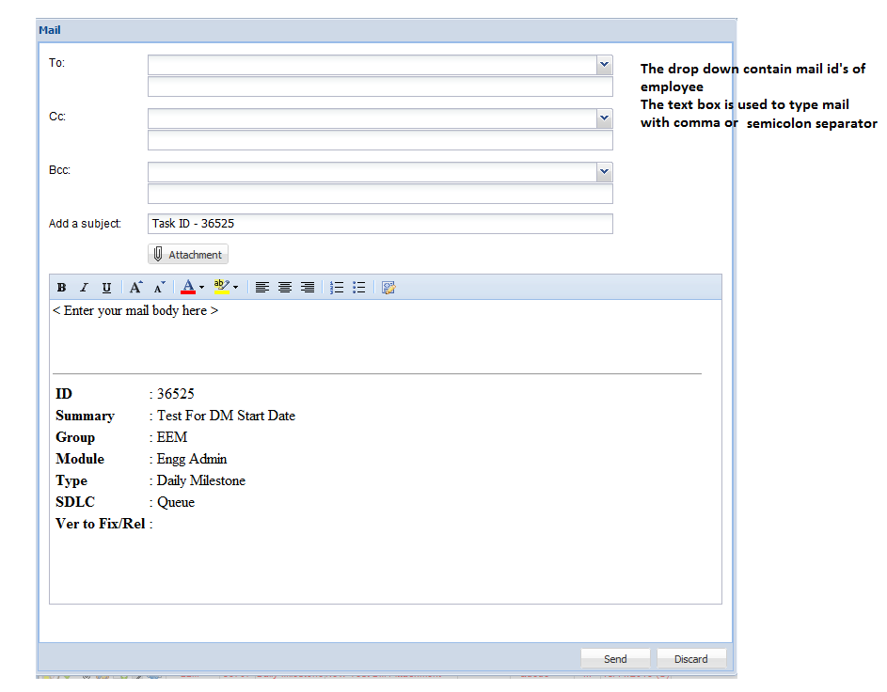

**4.3 Feature Description:**

Can we have a filter ability in MSM

**Changes:**

When Milestone manager is loaded the column is loaded with an image if u click on it. It will list out a list of unique values present in that column through which we can filter the MSM.

# Bug Fixes

**5.1 Bug Description**

Show overdue column in MSM for all

**Changes:**

Overdue column is considered as default column in MSM and also all the users who has saved the filter without will see the overdue column on load of MSM.

**5.2 Bug Description**

Change recent completion to recent accomplishment. Show tasks which has comment in yesterday and not in today in status

**Changes:**

On click of the plan button in MSM it lists out a list of tasks that is going to be worked for the day. If anything is written for today and yesterday it used to show up in the plan. Now in the plan it will show only the tasks that was written for today and if a task was worked yesterday and today is left blank meaning no work for the task is to be done for the day then that task shows up in recent completion. Also, Recent Completion band is changed to Recent accomplishment in MSM.

# Known Problems and Workarounds

None